Command
(Behavioural)

The Command pattern decouples the sender of a request from the object that performs the action, providing a way to encapsulate a request as an object and allowing for the execution of complex operations with ease.
By utilizing the Command pattern, we can decouple the invoker from the concrete actions performed. This decoupling allows for greater flexibility and extensibility in our application. New shapes can be easily added without modifying the existing code, simply by creating a new command object and registering it with the invoker.

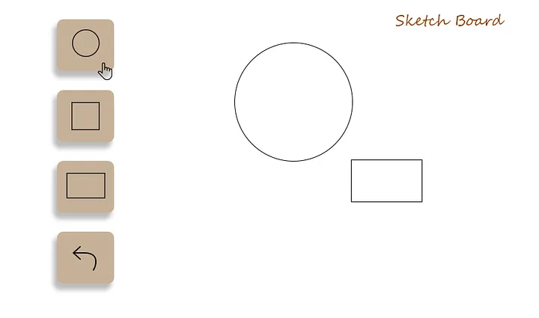
The DrawShape Class is responsible for the actual implementation of the creation of shapes.
class DrawShape{
String shape;

public DrawShape(String shape) {
this.shape = shape;
}

public void drawCircle() {
System.out.println("Drawing Circle..");
}

public void drawSquare() {
System.out.println("Drawing Square..");
}

public void drawRectangle() {
System.out.println("Drawing Rectangle..");
}

public void eraseShape(String shape) {
System.out.println("Erasing " + shape);
}
}

The main component of Command Design Pattern is the command interface. This is the central interface defining the execution and undo operations. It declares methods like execute() and undo() that concrete command classes implement.
interface Command {
public void execute();
public void undo(String shape);
}

As we have already defined the Command interface we have few concrete classes, these are the concrete implementations of the Command interface. Each concrete command class encapsulates a specific action and the necessary information to perform it.
class DrawCircleConcreteCommand implements Command {
DrawShape draw;

public DrawCircleConcreteCommand(DrawShape draw) {
this.draw = draw;
}

public void execute() {
draw.drawCircle();
}

public void undo(String shape) {
draw.eraseShape(shape);
}
}
class DrawSquareConcreteCommand implements Command {
DrawShape draw;

public DrawSquareConcreteCommand(DrawShape draw) {
this.draw = draw;
}

public void execute() {
draw.drawSquare();
}

public void undo(String shape) {
draw.eraseShape(shape);
}
}
class DrawRectangleConcreteCommand implements Command {
DrawShape draw;

public DrawRectangleConcreteCommand(DrawShape draw) {
this.draw = draw;
}

public void execute() {
draw.drawRectangle();
}

public void undo(String shape) {
draw.eraseShape(shape);
}
}

After setting up the actual implementation and concrete command classes we should have a invoker of the concrete command classes. The Invoker is responsible for invoking the commands and managing their execution. It receives a command object and triggers its execution by calling the execute() method. The Invoker doesn't have any knowledge of the concrete command or receiver objects, ensuring loose coupling.
class SketchBoard { //Invoker

Command command;

public void setCommand(Command command) {
this.command = command;
}

public void drawTheShape() {
command.execute();
}

public void eraseTheShape(String shape) {
command.undo(shape);
}
}

The Client is responsible for creating an instance of the Invoker class and the DrawShape class. We create instances of the concrete command classes (DrawCircleConcreteCommand, DrawSquareConcreteCommand, DrawRectangleConcreteCommand) and associate them with the DrawShape receiver.
public class Main { //Client
public static void main(String[] args) {

//Invoker
SketchBoard sketchBoard = new SketchBoard();
//Create a drawshape object this will be the receiver of the request
DrawShape drawShape = new DrawShape("Circle..");
//Creating Command object and passing receiver
Command drawCircle = new DrawCircleConcreteCommand(drawShape);
//pass the command to the invoker
sketchBoard.setCommand(drawCircle);
//simulate the icon we have chosen
sketchBoard.drawTheShape();
sketchBoard.eraseTheShape(drawShape.shape);

drawShape = new DrawShape("Square..");
Command drawSquare = new DrawSquareConcreteCommand(drawShape);
sketchBoard.setCommand(drawSquare);
sketchBoard.drawTheShape();
sketchBoard.eraseTheShape(drawShape.shape);

drawShape = new DrawShape("Recatangle..");
Command drawRectangle = new DrawRectangleConcreteCommand(drawShape);
sketchBoard.setCommand(drawRectangle);
sketchBoard.drawTheShape();
sketchBoard.eraseTheShape(drawShape.shape);

}

Output:
Drawing Circle..
Erasing Circle..
Drawing Square..
Drawing Rectangle..
Erasing Rectangle..

In the Command pattern, the sender (Invoker) and the object that performs the action (Receiver — DrawShape) are decoupled or separated from each other. The Invoker class does not need to know the specific details of how the drawing operations are performed or what shape is being drawn. It only needs to know how to execute the command.
By encapsulating the drawing operations within concrete command objects (DrawCircleConcreteCommand, DrawSquareConcreteCommand, DrawRectangleConcreteCommand), the Invoker doesn't need to have direct knowledge of the DrawShape or its methods. It interacts with the commands through the common Command interface, which declares the execute() method. This decoupling allows for flexibility and extensibility, as new commands can be easily added without modifying the Invoker class or impacting its functionality.

Command Design Pattern example (Remote Control)
Components of the Command Design Pattern:
- Command Interface
- Concrete Command Classes
- Invoker (Remote Control)
- Receiver (Devices)

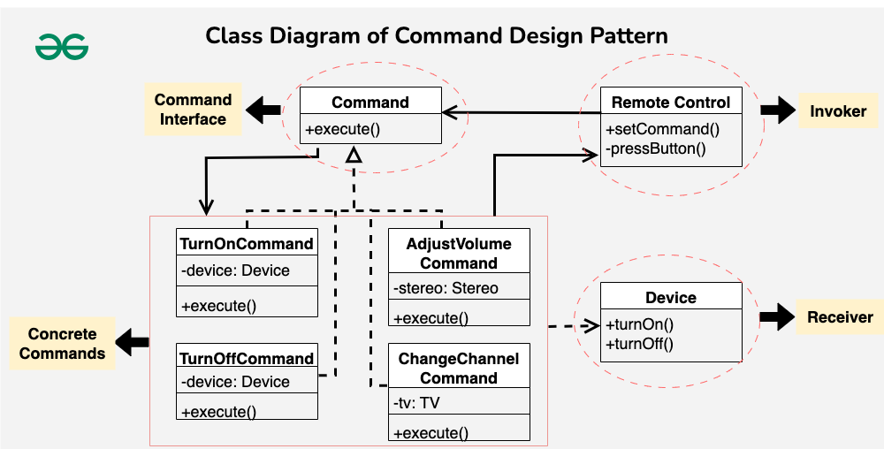
- Create the Command Interface: Define an interface or abstract class that declares the execute() method. This method will be called to carry out the action.
- Create Concrete Command Classes: Implement the command interface in multiple classes. Each class will represent a different command and will call the appropriate method on the receiver to perform the specific action.
- Define the Receiver Class: This class contains the actual logic that needs to be executed. The command objects will call methods on this receiver to perform actions.
- Create the Invoker Class: The invoker triggers the command’s execute() method but doesn’t know the details of the operation. It simply knows that it needs to call the command.
- Client Uses the Command: The client creates the concrete command objects and associates them with the receiver. It then assigns commands to the invoker, which will call them when needed.

The Receiver-Command relationship separates responsibilities, making it easy to add new devices or commands without messing with existing functionality.

Problem Statement:
Imagine you are tasked with designing a remote control system for various electronic devices in a smart home. The devices include a TV, a stereo, and potentially other appliances. The goal is to create a flexible remote control that can handle different types of commands for each device, such as turning devices on/off, adjusting settings, or changing channels.

1. Command Interface
// Command interface
public interface Command {
void execute();
}

2. Concrete Command Classes
// Concrete command for turning a device on
public class TurnOnCommand implements Command {
private Device device;

public TurnOnCommand(Device device) {
this.device = device;
}

@Override
public void execute() {
device.turnOn();
}
}
// Concrete command for turning a device off
public class TurnOffCommand implements Command {
private Device device;

public TurnOffCommand(Device device) {
this.device = device;
}

@Override
public void execute() {
device.turnOff();
}
}
// Concrete command for adjusting the volume of a stereo
public class AdjustVolumeCommand implements Command {
private Stereo stereo;

public AdjustVolumeCommand(Stereo stereo) {
this.stereo = stereo;
}

@Override
public void execute() {
stereo.adjustVolume();
}
}
// Concrete command for changing the channel of a TV
public class ChangeChannelCommand implements Command {
private TV tv;

public ChangeChannelCommand(TV tv) {
this.tv = tv;
}

@Override
public void execute() {
tv.changeChannel();
}
}

3. Receiver Classes (Devices)
// Receiver interface
public interface Device {
void turnOn();
void turnOff();
}

// Concrete receiver for a TV
public class TV implements Device {
@Override
public void turnOn() {
System.out.println("TV is now on");
}

@Override
public void turnOff() {
System.out.println("TV is now off");
}

public void changeChannel() {
System.out.println("Channel changed");
}
}

// Concrete receiver for a stereo
public class Stereo implements Device {
@Override
public void turnOn() {
System.out.println("Stereo is now on");
}

@Override
public void turnOff() {
System.out.println("Stereo is now off");
}

public void adjustVolume() {
System.out.println("Volume adjusted");
}
}

4. Invoker Class (Remote Control)
// Invoker
public class RemoteControl {
private Command command;

public void setCommand(Command command) {
this.command = command;
}

public void pressButton() {
command.execute();
}
}

The invoker class holds a reference to a Command object and triggers its execution through the execute() method. The invoker doesn’t know the specific details of the command or the devices. It simply calls the execute() method on the current command, allowing for flexible and dynamic control over different devices.

// Example usage
public class CommandPatternExample {
public static void main(String[] args) {
// Create devices
TV tv = new TV();
Stereo stereo = new Stereo();

// Create command objects
Command turnOnTVCommand = new TurnOnCommand(tv);
Command turnOffTVCommand = new TurnOffCommand(tv);
Command adjustVolumeStereoCommand = new AdjustVolumeCommand(stereo);
Command changeChannelTVCommand = new ChangeChannelCommand(tv);

// Create remote control
RemoteControl remote = new RemoteControl();

// Set and execute commands
remote.setCommand(turnOnTVCommand);
remote.pressButton(); // Outputs: TV is now on

remote.setCommand(adjustVolumeStereoCommand);
remote.pressButton(); // Outputs: Volume adjusted

remote.setCommand(changeChannelTVCommand);
remote.pressButton(); // Outputs: Channel changed

remote.setCommand(turnOffTVCommand);
remote.pressButton(); // Outputs: TV is now off
}
}

Output:
TV is now on
Volume adjusted
Channel changed
TV is now off

When to use the Command Design Pattern
- Decoupling is Needed:
  - In order to separate the requester making the request (the sender) from the object executing it, use the Command Pattern.
  - Your code will become more expandable and adaptable as a result.
- Undo/Redo Functionality is Required:
  - If you need to support undo and redo operations in your application, the Command Pattern is a good fit.
  - Each command can encapsulate an operation and its inverse, making it easy to undo or redo actions.
- Support for Queues and Logging:
  - If you want to maintain a history of commands, log them, or even put them in a queue for execution, the Command Pattern provides a structured way to achieve this.
- Dynamic Configuration:
  - When you need the ability to dynamically configure and assemble commands at runtime, the Command Pattern allows for flexible composition of commands.

When not to use the Command Design Pattern
- Simple Operations:
  - For very simple operations or one-off tasks, introducing the Command Pattern might be overkill.
  - It’s beneficial when you expect your operations to become more complex or when you need to support undo/redo.
- Tight Coupling is Acceptable:
  - If the sender and receiver of a request are tightly coupled and changes in one do not affect the other, using the Command Pattern might introduce unnecessary complexity.
- Overhead is a Concern:
  - In scenarios where performance and low overhead are critical factors, introducing the Command Pattern might add some level of indirection and, in turn, impact performance.
- Limited Use of Undo/Redo:
  - If your application does not require undo/redo functionality and you do not anticipate needing to support such features in the future, the Command Pattern might be unnecessary complexity.

Resources:
https://readmedium.com/command-design-pattern-in-java-7d06dfdd31
https://www.geeksforgeeks.org/command-pattern/

